Assignment 10
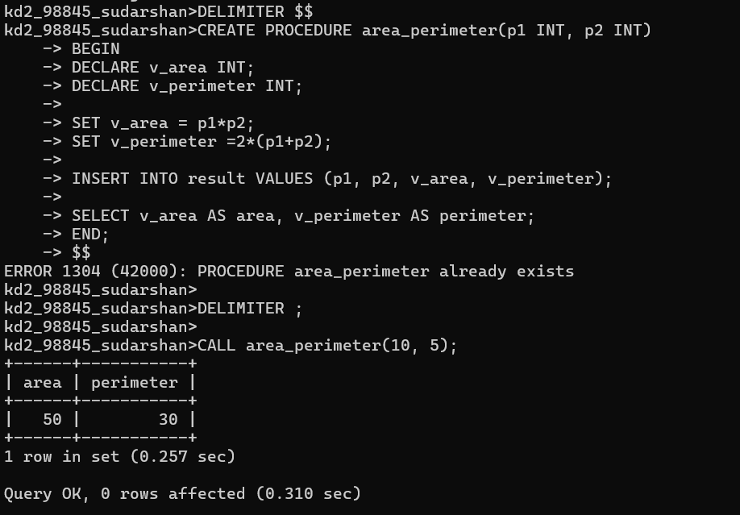
1. Write a procedure that computes the perimeter and the area of a rectangle. Define your own values for the length and width. (Assuming that L and W are the length and width of the rectangle, Perimeter = 2*(L+W) and Area = L*W.

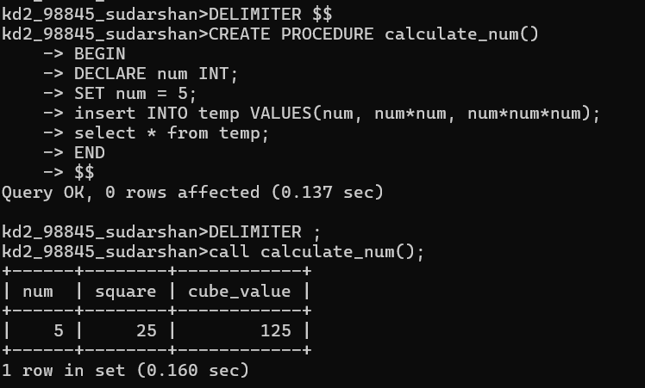
2. Write a procedure that declares an integer variable called num, assigns a value to it, computes and inserts into the temp table the value of the variable itself, its square, and its cube.

3. Create a procedure to Convert a temperature in Fahrenheit (F) to its equivalent in Celsius (C) and vice versa. The required formulae are C= (F-32) *5/9 F= 9/5*C + 32
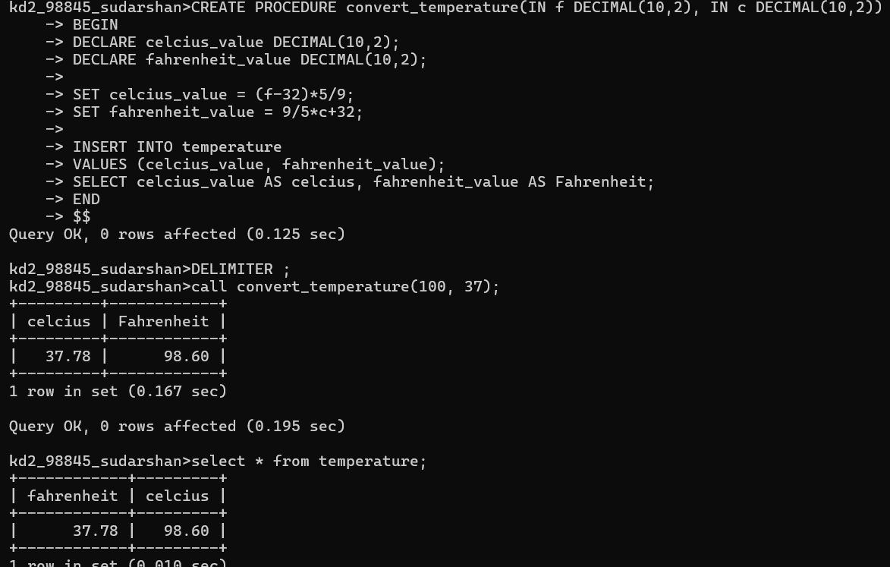

4. Create a procedure to Convert a number of inches into yards, feet, and inches. For example, 124 inches equals 3 yards, 1 foot, and 4 inches.
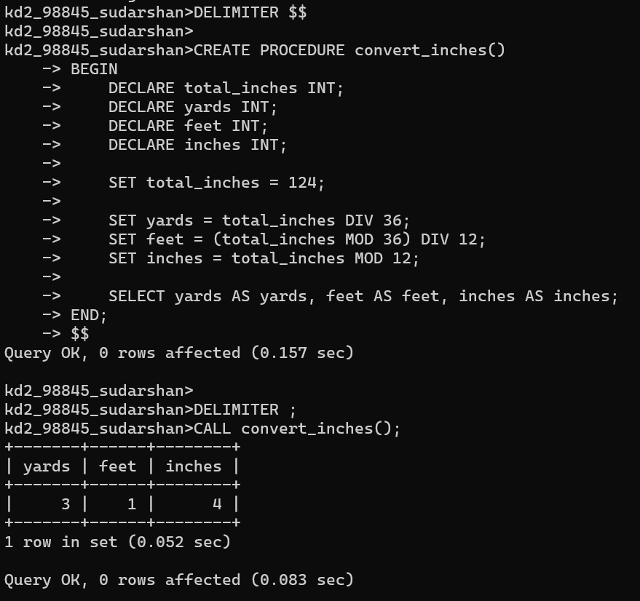
5. Create a procedure to read two real numbers and tell whether the product of the two numbers is equal to or greater than 100.
